**FOODIEZZ**

**Get Addicted to FOOD**

**AISSCE 2020 EXAMINATION**

**[As a part of the Informatics Practices Course (265)]**

**Submitted by:**

***Soham Lad***

**Roll no: *11613543***

**Under the Guidance of:**

***Mr. Durga M. Parida***

***[PGT (COMP. SC.)]***

2019-20

Soham

FOODIEZZ

ACKNOWLEDGEMENT

I undertook this project work, as the part of my XII-Informatics Practices course. I had tried to apply my best of knowledge and experience, gained during the study and class work experience. However, developing software system is generally a quite complex and time-consuming process. It requires a systematic study, insight vision and professional approach during the design and development. Moreover, the developer always feels the need, the help and good wishes of the people near you, who have considerable experience and idea. I would like to extend my sincere thanks and gratitude to my teacher Mr.Durga M. Parida. I am very much thankful to our Principal Mr. Shailesh Sutaria for giving valuable time and moral support to develop this software. I would like to take the opportunity to extend my sincere thanks and gratitude to my parents for being a source of inspiration and providing time and freedom to develop this software project.

I also feel indebted to my parents and friends for the valuable suggestions during the project work.

**XII Science:-**

1. Vatsal Parmar
2. Harsh Khunt
3. Soham Lad
4. Ayush Patil

SYSTEM IMPLEMENTATION

* **The Hardware used:**

While developing the system, the used hardware are:

1. Processor - Intel® Pentium® CPU G2020 2.90GHz
2. Installed Memory (RAM) - 2.00 GB (1.89 usable)
3. System Type - 32-bit Operating System

* **The Softwares used:**

1. Windows 7 Ultimate Copyright © 2007 Microsoft Corporation as Operating System.
2. Java Netbeans 7.1.1 and 8.2 as Front-end Development environment.
3. MySQL as Back-end Sever with Database for Testing.
4. MS-Word 2007 for documentation.

* **Other Requirement-**

1. The PC must have MySQL server with user (root) and password (mysql) .
2. Folder named ‘Vatsal’ should be saved in Local Disk (D:) to run the program correctly.
3. Start ->Program -> MySQL ->MySQL Server ->MySQL Command Line Client

To create a MySQL database from a txt file , simply follow the following steps.

Step 1: Copy the MySQL Script.txt from “D:\Vatsal\MySQL Script”

Step 2: Open MySQL and paste the following command to create the database named vatsalproject.

Project Report On:

Online Food Ordering Application

**FOODIEZZ**

**Get Addicted to FOOD**

CONTENTS

|  |  |  |
| --- | --- | --- |
|  | Introduction | 6 |
|  | Objective & Scope of the Project | 7 |
|  | Data Dictionary | 9 |
|  | Screenshots and Source Code | 11 |
|  | References | 42 |

INTRODUCTION

This software project is developed to automate the functionalities of a User Friendly Online Food Ordering Application (FOODIEZZ). The purpose of the software project is to develop a program which provides a friendly interface for the user to order food from wide range of restaurants at home and buy them according to their choice. This program mainly brings forth the usage of GUI programming in the daily usage over the network. The program when made to work over the network can prove to be an ultimate way of interaction between the User and the Restaurants.

A MIS mainly consists of a computerized database, a collection of interrelated tables for a particular subject or purpose, capable to produce different reports relevant to the user. An application program is tied with the database for easy access and interface to the database. Using Application program or front-end, we can store, retrieve and manage all information in proper way. This software, being simple in design and working, does not require much of training to users, and can be used as a powerful tool for the automating the Online Food Ordering.

During coding and design of the software Project, Java Netbeans IDE, a powerful front-end tool is used for getting Graphical User Interface (GUI) based integrated platform and coding simplicity. As a back-end a powerful, open source RDBMS, My SQL is used as per requirement of the CBSE curriculum of Informatics Practices Course.

Objective And Scope Of Project

The objective of the software project is to develop a computerized MIS to automate the Online Food Ordering. This software project is also aimed to enhance the current record keeping system, which will help managers to retrieve the up-to-date information at right time in right shape.

The proposed software system is expected to do the following functionality:

1. To provide a user friendly, Graphical User Interface (GUI) based integrated and centralized environment for MIS activities.
2. The proposed system should maintain all the records and transactions, and should generate the required reports and information when required.
3. To provide graphical and user-friendly interface to interact with a centralized database based on client-server architecture.
4. To identify the critical operation procedure and possibilities of simplification using modern IT tools and practices. In its current scope, the software enables user to retrieve and update the information from centralized database designed with MySQL. This software does not require much training time of the users due to limited functionality and simplicity. During the development of Online Food Ordering Application ‘Vogue’ project, Java Netbeans IDE, a powerful, open source event-driven form-based development environment is used for modular design and future expandability of the system.

Despite of the best effort of the developer, the following limitations and functional boundaries are visible, which limits the scope of this application software.

1. This software can store records and produce reports in pre-designed format in soft copy. There is no facility yet to produce customized reports. Only specified reports are covered.
2. There is no provision to update Username.
3. Some application areas like saving of last purchase dates are not implemented in the project. It facilitates the buyer to go through the products of the store and choose as per his wish to buy the product. This project is made by keeping in that it is to be used over the network, which can facilitate ease of shopping. So far as future scope of the project is concerned, firstly it is open to any modular expansion i.e. other modules or functions can be designed and embedded to handle the user need in future. Any part of the software and reports can be modified independently without much effort.

Data Dictionary

**Table: Login**

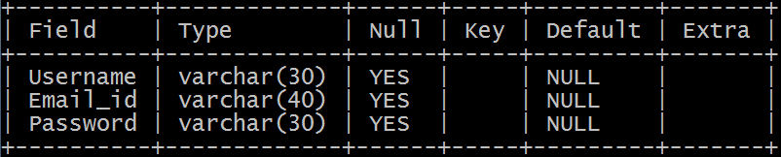

All Username, Email id, Password is stored in Login Table.

**Table: Location**

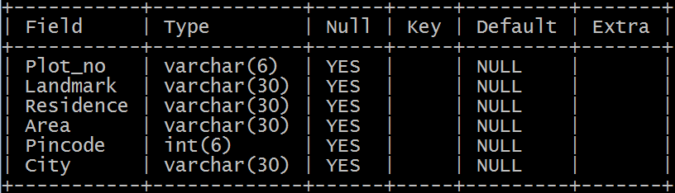

All Address is stored in Location Table

**Table: Cart**

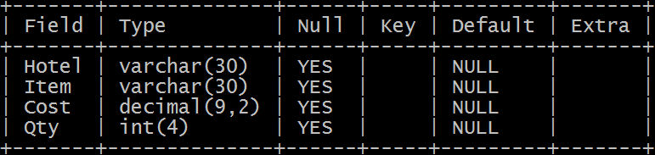

All selected items of Restaurants is stored Cart Table with Hotel name, Item name, Cost, Quantity

**Table: Vatsal_Parmar (Username)**

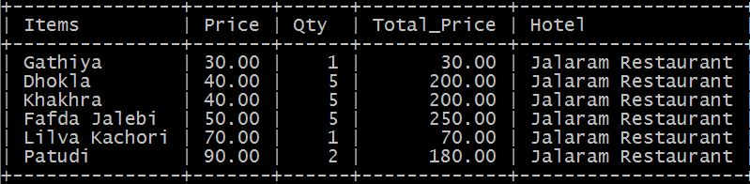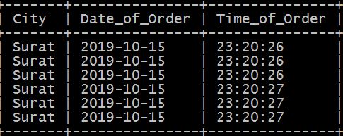

All Records of Paid Order is stored in Vatsal_Parmar (Username Table), having Item name, Price, Quantity (Qty), Total Price, Hotel name, City, Date of Order, Time of Order

Screenshots and Source Code

* On Opening of Project ‘Welcome Page Frame’ :

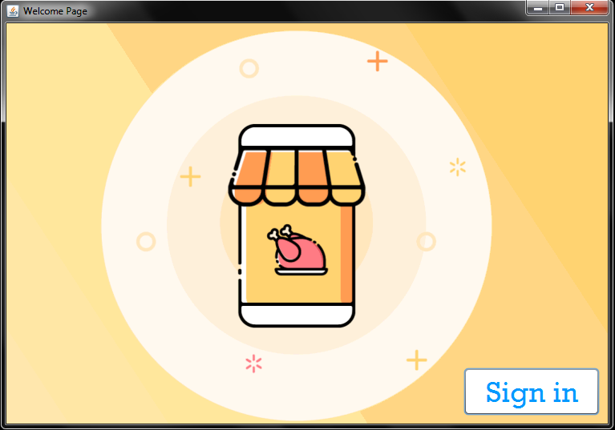

* Code under H:\New folder\btn\signin.JPG Button :

_2_Login.main(null);

this.dispose();

* ‘Login Page Frame’ opens on Clicking H:\New folder\btn\signin.JPGButton :

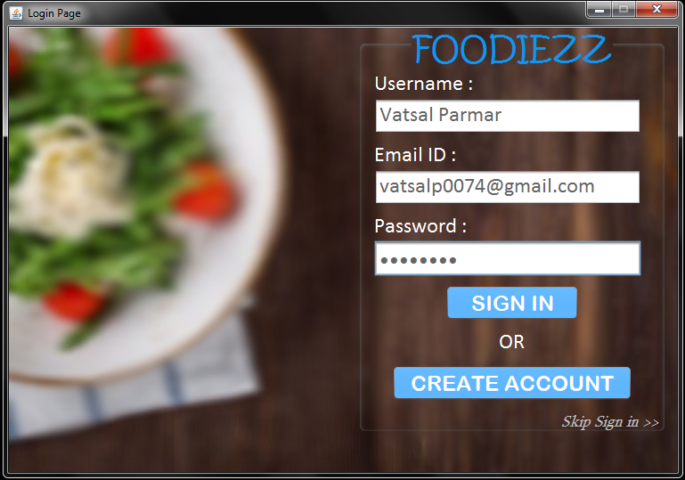

* Items to be Imported :

import java.awt.Color;

import java.sql.Connection;

import java.sql.DriverManager;

import java.sql.ResultSet;

import java.sql.Statement;

import javax.swing.JOptionPane;

* Code under Opening of Form :

setLocationRelativeTo(null);

* Code under H:\New folder\btn\skipsign.JPG Label Click Event :

this.dispose();

_3_Location.main(null);

* Code under H:\New folder\btn\createaccbtn.JPG Button :

_2_Create_Account.main(null);

this.dispose();

* Code under H:\New folder\btn\Signinbtn.JPG Button :

String Emailid = Email.getText(), Pwd = new String (Pass.getPassword()), Uname = Usern.getText();

if(Emailid.isEmpty() || Pwd.isEmpty() || Uname.isEmpty()){

JOptionPane.showMessageDialog(this, "<html><font size = 15 face = Rockwell color = Green>Fill All The Fields", null, 2);}

else{

try{

Class.forName("java.sql.Driver");

Connection c = DriverManager.getConnection("jdbc:mysql://localhost/vatsalproject", "root", "mysql");

Statement stat = c.createStatement();

String query = "Select * from login where Username = '"+ Uname +"';";

ResultSet rs = stat.executeQuery(query);

while (rs.next()){

String ei = rs.getString("Email_id");

String pas = rs.getString("Password");

String un = rs.getString("Username");

if(Emailid.equals(ei) && Pwd.equals(pas)){

int Ans = JOptionPane.showConfirmDialog(this, "<html><font color = green face = Rockwell size = 7>Successfully Logged in<br>Go Ahead?", null, 0, 1);

if(Ans == JOptionPane.YES_OPTION){

_3_Location.main(null);

this.dispose();

}break;

} else{

if(!Emailid.equals(ei) && Pwd.equals(pas))

JOptionPane.showConfirmDialog(this, "<html><font color = red>Incorrect Email ID", null, -1, 0);

if(!Pwd.equals(pas) && Emailid.equals(ei))

JOptionPane.showConfirmDialog(this, "<html><font color = red>Incorrect Password", null, -1, 0);

if(!Emailid.equals(ei) && !Pwd.equals(pas))

JOptionPane.showConfirmDialog(this, "<html><font color = red>Incorrect Email ID and Password", null, -1, 0);

}

}

}

catch(Exception e){

JOptionPane.showMessageDialog(this, "Error in Signing in", null, 2);

}

}

* On Clicking H:\New folder\btn\skipsign.JPG Label :

Location Page Frame (Pg. no.: 19) will open without Signing in.

* On Clicking H:\New folder\btn\Signinbtn.JPG Button :

Location Page Frame (Pg. no.: 19) will open with Signing in.

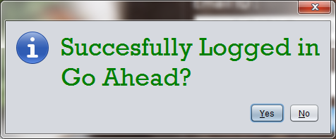

* ‘Create Account Frame’ opens on Clicking H:\New folder\btn\createaccbtn.JPG Button :

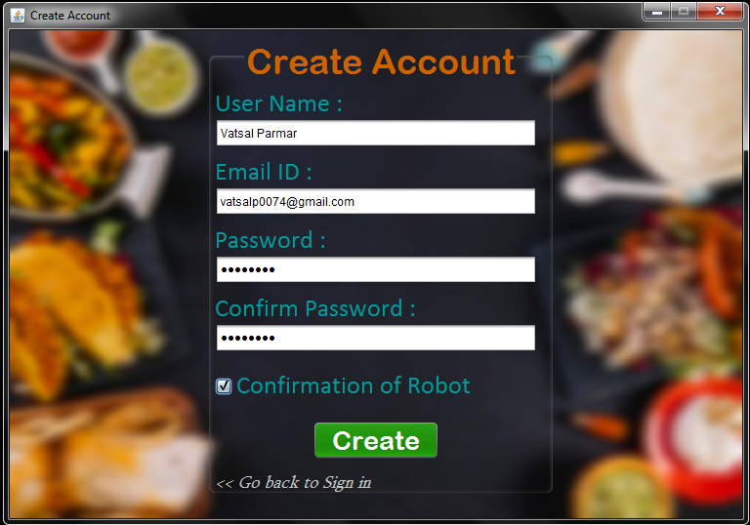

* Items to be Imported :

import java.awt.Color;

import java.sql.Connection;

import java.sql.DriverManager;

import java.sql.ResultSet;

import java.sql.Statement;

import javax.swing.JOptionPane;

* Code under Opening of Form :

setLocationRelativeTo(null);

* Code under H:\New folder\btn\createbtn.JPG Button :

String Un = User.getText(), Emailid = Email.getText(), Pwd = new String(Pass.getPassword()), CPwd = new String(ConPass.getPassword());

if(Un.isEmpty() || Emailid.isEmpty() || Pwd.isEmpty() || CPwd.isEmpty())

JOptionPane.showMessageDialog(this, "<html><font face = Rockwell color = green size = 15>Fill All The Fields",null,-1);

else{

if(ConRobo.isSelected()){

try{

Class.forName("java.sql.Driver");

Connection c = DriverManager.getConnection("jdbc:mysql://localhost/vatsalproject", "root", "mysql");

Statement stat = c.createStatement();

String query1 = "Select * from login; ";

ResultSet rs = stat.executeQuery(query1);

while (rs.next()){

String ei = rs.getString("Email_ID");

String un = rs.getString("Username");

if(Emailid.equals(ei))

JOptionPane.showConfirmDialog(this, "<html><font face = Rockwell size = 15>Email ID has been used", null, -1, 0);

if(!Emailid.equals(ei) && Pwd.equals(CPwd)){

String query = "Insert into login values('" + Un + "','" + Emailid + "','" + Pwd + "');";

stat.executeUpdate(query);

_2_Login.main(null);

this.dispose();

break;

}

else{

if(!Pwd.equals(CPwd))

JOptionPane.showMessageDialog(this, "<html><font face = Rockwell color = blue size = 15>Password doesn not match to Confirm Password",null,1);

break;

}

}

}

catch(Exception e){

JOptionPane.showConfirmDialog(this, "<html><font face = Rockwell size = 15>This Username already exists<br> OR <br>System Error ", null, -1, 0);

}

}

else

JOptionPane.showMessageDialog(this, "Confirm that you are not a Robot");

}

* Code under H:\New folder\btn\gobacksign.JPG Label Click Event :

this.dispose();

_2_Login.main(null);

* Code under H:\New folder\btn\Conrobo1.JPG CheckBox :

Recaptcha.main(null);

ConRobo.setSelected(false);

* On Clicking H:\New folder\btn\gobacksign.JPG Button :

Login Page Frame (Pg. no.: 12) will open to Sign in.

* ‘Recaptcha Frame’ opens on Clicking H:\New folder\btn\Conrobo1.JPG CheckBox :
* 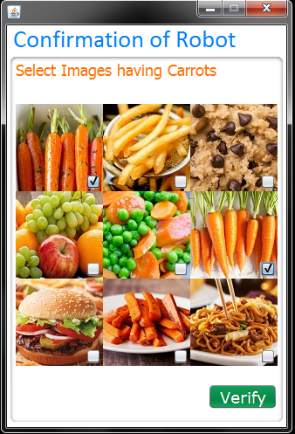Code underH:\New folder\btn\verify.JPGCheckBox :

if(jCheckBox1.isSelected() && jCheckBox5.isSelected() && jCheckBox6.isSelected() && jCheckBox8.isSelected() && !jCheckBox2.isSelected() && !jCheckBox3.isSelected() && !jCheckBox4.isSelected() && !jCheckBox7.isSelected() && !jCheckBox9.isSelected()){

JOptionPane.showMessageDialog(this, "<html><font size = 15 face = Rockwell color = blue>Verified");

this.dispose();

_2_Create_Account.ConRobo.setSelected(true);

}

else{

JOptionPane.showConfirmDialog(this, "<html><font color=red >Error Robot not Verified", "Error", -1, 0);

this.dispose();

}

* On Clicking H:\New folder\btn\verify.JPG Button :

Verified Message will popup and then Confirmation of Robot will be

checked H:\New folder\btn\Conrobo.JPG

* On Clicking H:\New folder\btn\createbtn.JPG Button :

Account will be created and Login Page Frame will open to Sign in.

* ‘Location Frame’ opens on Clicking H:\New folder\btn\Signinbtn.JPG Button OR H:\New folder\btn\skipsign.JPG Label :

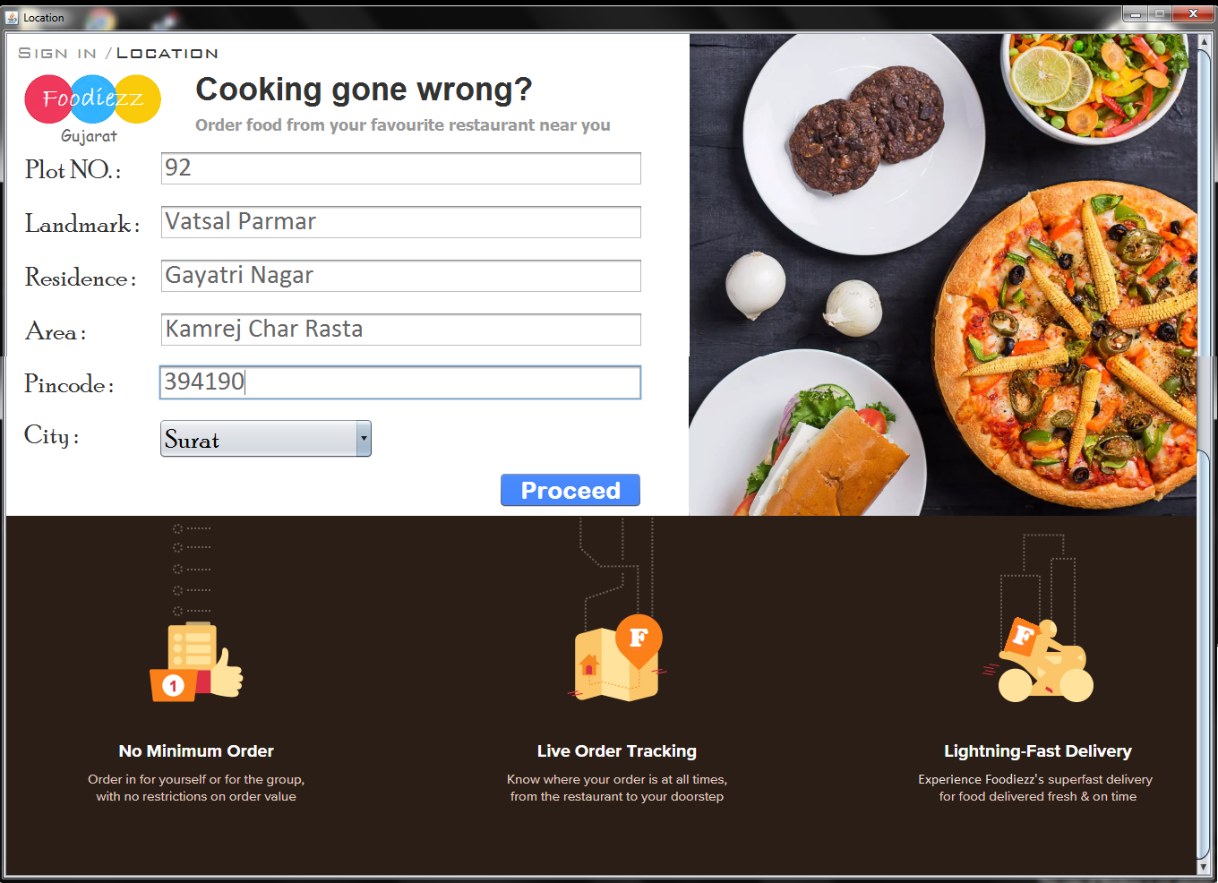

Available Cities: Surat, Ahemdabad

* Items to be Imported :

import javax.swing.JOptionPane;

import java.sql.Connection;

import java.sql.ResultSet;

import java.sql.DriverManager;

import java.sql.Statement;

import javax.swing.ImageIcon;

* Code under Opening of Form :

setLocationRelativeTo(null);

* Code under H:\New folder\btn\proceed.JPG Button :

String Pl = Plotno.getText(), Rsd = Residence.getText(), Ld = Landmark.getText(), Pn = Pincode.getText(), Ar = Area.getText();

if(Pl.isEmpty() || Rsd.isEmpty() || Ld.isEmpty() || Pn.isEmpty() || City.getSelectedItem() == null || City.getSelectedIndex() == 0)

JOptionPane.showMessageDialog(this, "<html><font size = 15 color = orange face = Rockwell>Fill All Fields",null,2);

else{

try{

Class.forName("java.sql.Driver");

con = DriverManager.getConnection("jdbc:mysql://localhost/vatsalproject", "root", "mysql");

stat = con.createStatement();

String query1 = "Delete from Location;";

String query = "Insert into location values ('" + Pl + "','" + Ld + "','" + Rsd + "','" + Ar + "'," + Pn + ",'" + City.getSelectedItem() + "');";

stat.executeUpdate(query1);

stat.executeUpdate(query);

JOptionPane.showMessageDialog(this, "<html><font size = 15 face = Rockwell color = Red>Loca</font><<font size = 15 face = Rockwell color = Orange>tion A</font><font size = 15 face = Rockwell color = Green>dded", null, -1);

if(City.getSelectedIndex() == 1){

_4_Main_Order_Gujarat_Ahemdabad.main(null);

this.dispose();}

if(City.getSelectedIndex() == 2){

_4_Main_Order_Gujarat_Surat.main(null);

this.dispose();}

}

catch(Exception e){

JOptionPane.showMessageDialog(this, "<html><font color = red face = Rockwell size = 15>Error in Proceeding <br> or <br> Pincode not valid", null, 2);

}

}

* Restaurants(Surat) opens on Clicking H:\New folder\btn\proceed.JPG Button:

Address will be added to MySQL Data in Table : Location (Pg. no.: 9) and Restaurants of selected city will be displayed in another frame. Ex – Surat

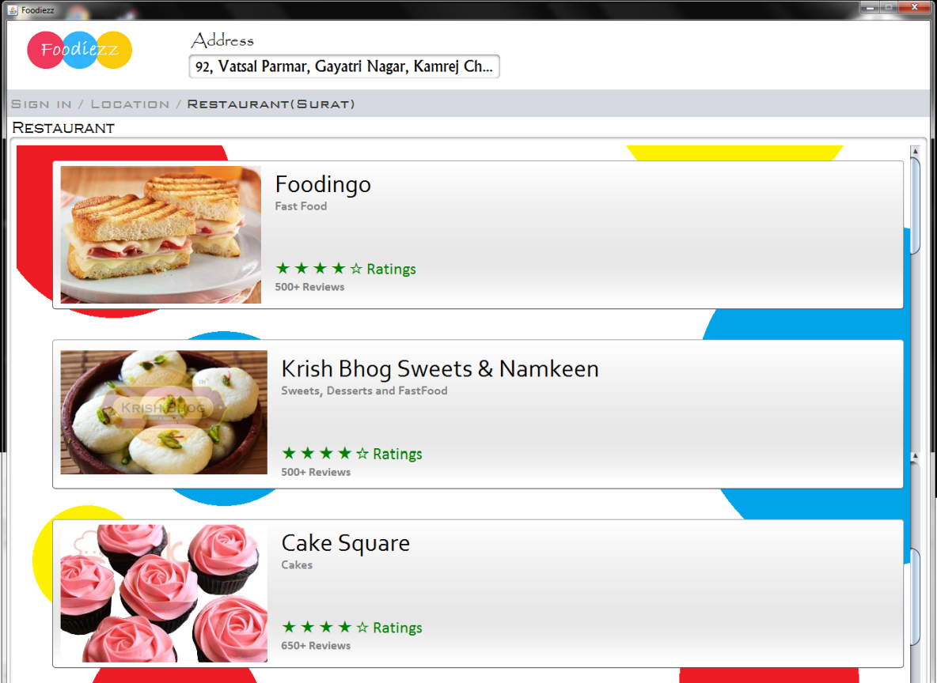

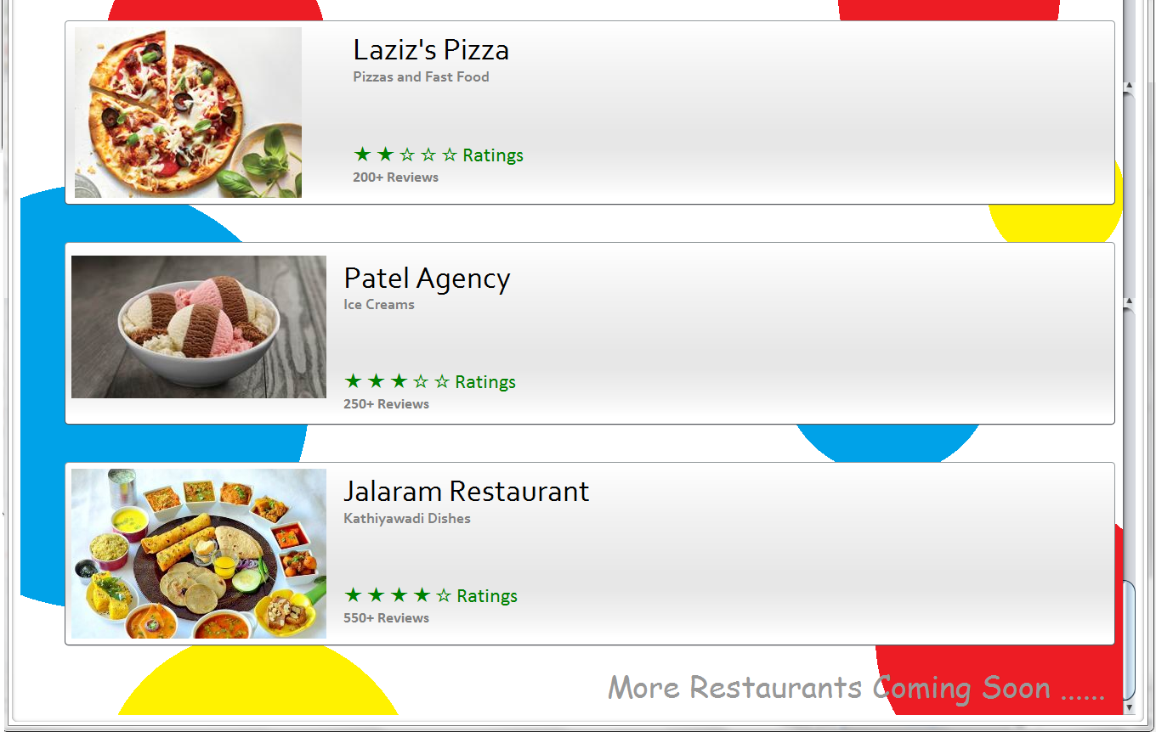

Total No. of Restaurants Available: 6 Restaurants

* Items to be Imported :

import java.sql.Connection;

import java.sql.DriverManager;

import java.sql.ResultSet;

import java.sql.Statement;

import javax.swing.JOptionPane;

* Code under Opening of Form :

setLocationRelativeTo(null);

try{

Class.forName("java.sql.Driver");

con = DriverManager.getConnection("jdbc:mysql://localhost/vatsalproject", "root", "mysql");

Statement stat = con.createStatement();

String query = "Select * from Location;";

rs = stat.executeQuery(query);

while(rs.next()){

String pn = rs.getString("Plot_no");

String ar = rs.getString("Area");

String land = rs.getString("Landmark");

String pin = rs.getString("Pincode");

String ct = rs.getString("City");

String resi = rs.getString("Residence");

Address.setText(pn + ", " + land + ", " + resi + ", " + ar + ", " + ct + ", Gujarat" + " - " + pin);

Address.setToolTipText(pn + ", " + land + ", " + resi + ", " + ar + ", " + ct + ", Gujarat"+ " - " + pin);

}

}

catch(Exception e){

JOptionPane.showMessageDialog(this, "Error in Address", null, 2);

}

* Code under ‘Jalaram Restaurant’ Button :

Restaurants.Surat_Jalaram_Restaurant.main(null);

this.dispose();

* ‘Jalaram Restaurant Frame’ opens on Clicking ‘Jalaram Restaurant’ Button:

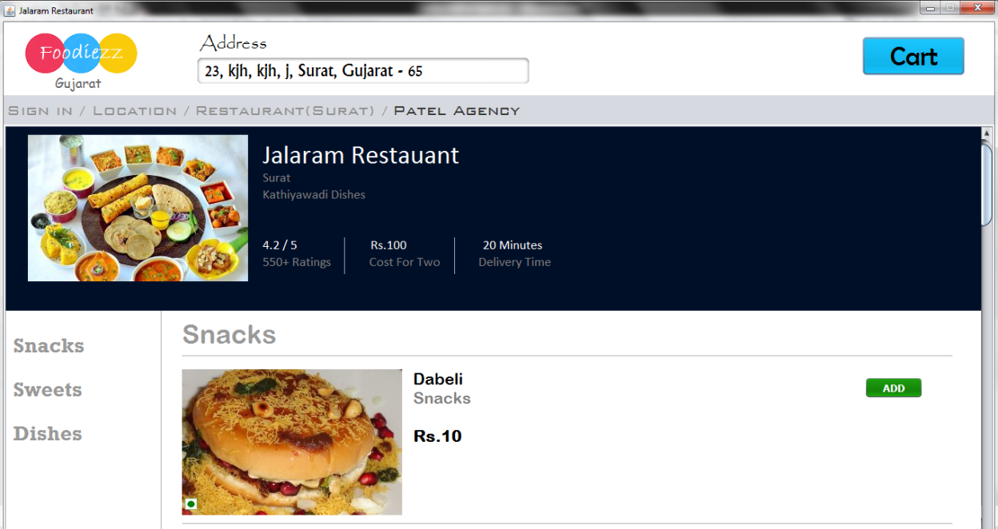

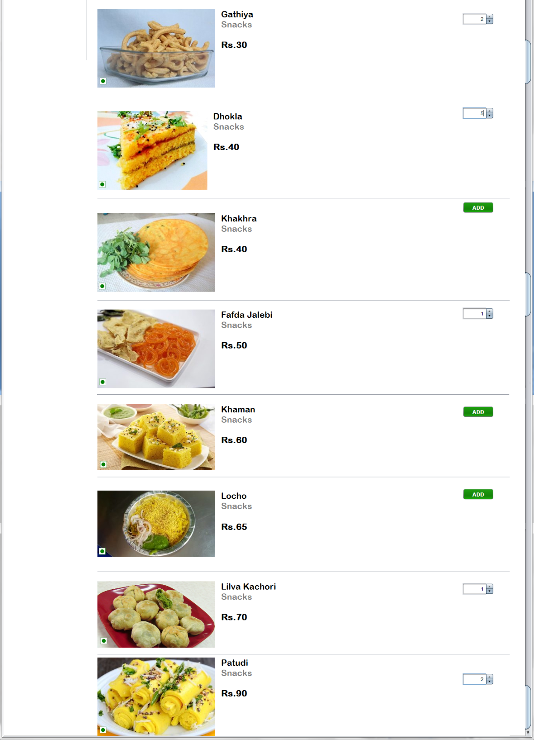

* Items to be Imported :

import Project_Frame._3_Location;

import java.awt.Color;

import java.sql.Connection;

import java.sql.DriverManager;

import java.sql.ResultSet;

import java.sql.Statement;

import javax.swing.JOptionPane;

* public class Surat_Jalaram_Restaurant extends javax.swing.JFrame {

Connection con;

ResultSet rs;

Statement stat;

}

* Code under Opening of Form :

setLocationRelativeTo(null);

try{

Class.forName("java.sql.Driver");

con = DriverManager.getConnection("jdbc:mysql://localhost/vatsalproject", "root", "mysql");

stat = con.createStatement();

String query = "Select * from Location;";

rs = stat.executeQuery(query);

while(rs.next()){

String pn = rs.getString("Plot_no");

String ar = rs.getString("Area");

String land = rs.getString("Landmark");

String pin = rs.getString("Pincode");

String ct = rs.getString("City");

String resi = rs.getString("Residence");

Address.setText(pn + ", " + land + ", " + resi + ", " + ar + ", " + ct + ", Gujarat" + " - " + pin);

Address.setToolTipText(pn + ", " + land + ", " + resi + ", " + ar + ", " + ct + ", Gujarat" + " - " + pin);

}

}

catch(Exception e){

JOptionPane.showMessageDialog(this, "Error in Adress",null,-2);

}

C1.setVisible(false);

C2.setVisible(false);

C3.setVisible(false);

C4.setVisible(false);

C5.setVisible(false);

C6.setVisible(false);

C7.setVisible(false);

C8.setVisible(false);

C9.setVisible(false);

C10.setVisible(false);

C11.setVisible(false);

C12.setVisible(false);

C13.setVisible(false);

C14.setVisible(false);

C15.setVisible(false);

C16.setVisible(false);

C17.setVisible(false);

C18.setVisible(false);

C19.setVisible(false);

C20.setVisible(false);

C21.setVisible(false);

C22.setVisible(false);

C23.setVisible(false);

C24.setVisible(false);

C25.setVisible(false);

C26.setVisible(false);

C27.setVisible(false);

SnacksPanel.setVisible(true);

DishPanel.setVisible(false);

SweetPanel.setVisible(false);

* Code under H:\New folder\btn\Add.JPG Button :

C1.setVisible(true);

Add1.setVisible(false);

C1.setValue(1);

* Code under H:\New folder\btn\cart.JPG Button :

int c1, c2, c3, c4, c5, c6, c7, c8, c9, c10, c11, c12, c13, c14, c15, c16, c17, c18, c19, c20, c21, c22, c23, c24, c25, c26, c27;

c1 = (int) C1.getValue();

c2 = (int) C2.getValue();

c3 = (int) C3.getValue();

c4 = (int) C3.getValue();

c5 = (int) C4.getValue();

c6 = (int) C5.getValue();

c7 = (int) C7.getValue();

c8 = (int) C8.getValue();

c9 = (int) C9.getValue();

c10 = (int) C10.getValue();

c11 = (int) C11.getValue();

c12 = (int) C6.getValue();

c13 = (int) C13.getValue();

c14 = (int) C14.getValue();

c15 = (int) C15.getValue();

c16 = (int) C16.getValue();

c17 = (int) C17.getValue();

c18 = (int) C18.getValue();

c19 = (int) C19.getValue();

c20 = (int) C20.getValue();

c21 = (int) C21.getValue();

c22 = (int) C22.getValue();

c23 = (int) C23.getValue();

c24 = (int) C24.getValue();

c25 = (int) C25.getValue();

c26 = (int) C26.getValue();

c27 = (int) C27.getValue();

if(c1 > 0 || c2 > 0 || c3 > 0 || c4 > 0 || c5 > 0 || c6 > 0 || c7 > 0 || c8 > 0 || c9 > 0 || c10 > 0 || c11 > 0 || c12 > 0 || c13 > 0 || c14 > 0 || c15 > 0 || c16 > 0 || c17 > 0 || c18 > 0 || c19 > 0 || c20 > 0 || c21 > 0 || c22 > 0 || c23 > 0 || c24 > 0 || c25 > 0 || c26 > 0 || c27 > 0 ){

try {

Class.forName("java.sql.Driver");

con = DriverManager.getConnection("jdbc:mysql://localhost/vatsalproject", "root", "mysql");

stat = con.createStatement();

String query1 = "Delete from cart;";

stat.executeUpdate(query1);

if (c1 > 0) {

String query = "Insert into cart values ('Jalaram Restaurant', 'Dabeli', 15," + c1 + ");";

stat.executeUpdate(query);

}

if (c2 > 0) {

String query = "Insert into cart values ('Jalaram Restaurant', 'Gathiya', 30," + c2 + ");";

stat.executeUpdate(query);

}

if (c3 > 0) {

String query = "Insert into cart values ('Jalaram Restaurant', 'Dhokla', 40," + c3 + ");";

stat.executeUpdate(query);

}

if (c4 > 0) {

String query = "Insert into cart values ('Jalaram Restaurant', 'Khakhra', 40," + c4 + ");";

stat.executeUpdate(query);

}

if (c5 > 0) {

String query = "Insert into cart values ('Jalaram Restaurant', 'Fafda Jalebi', 50," + c5 + ");";

stat.executeUpdate(query);

}

if (c6 > 0) {

String query = "Insert into cart values ('Jalaram Restaurant', 'Khaman', 60," + c6 + ");";

stat.executeUpdate(query);

}

if (c7 > 0) {

String query = "Insert into cart values ('Jalaram Restaurant', 'Locho', 65," + c7 + ");";

stat.executeUpdate(query);

}

if (c8 > 0) {

String query = "Insert into cart values ('Jalaram Restaurant', 'Lilva Kachori', 70," + c8 + ");";

stat.executeUpdate(query);

}

if (c9 > 0) {

String query = "Insert into cart values ('Jalaram Restaurant', 'Patudi', 90," + c9 + ");";

stat.executeUpdate(query);

}

if (c10 > 0) {

String query = "Insert into cart values ('Jalaram Restaurant', 'Churme Ka Ladoo', 50," + c10 + ");";

stat.executeUpdate(query);

}

if (c11 > 0) {

String query = "Insert into cart values ('Jalaram Restaurant', 'Dudh Pauva', 50," + c11 + ");";

stat.executeUpdate(query);

}

if (c12 > 0) {

String query = "Insert into cart values ('Jalaram Restaurant', 'Magaj na Ladoo', 60," + c12 + ");";

stat.executeUpdate(query);

}

if (c13 > 0) {

String query = "Insert into cart values ('Jalaram Restaurant', 'Ravana Ladoo', 65," + c13 + ");";

stat.executeUpdate(query);

}

if (c14 > 0) {

String query = "Insert into cart values ('Jalaram Restaurant', 'Gajjar Ka Halwa', 70," + c14 + ");";

stat.executeUpdate(query);

}

if (c15 > 0) {

String query = "Insert into cart values ('Jalaram Restaurant', 'Ghughra', 75," + c15 + ");";

stat.executeUpdate(query);

}

if (c16 > 0) {

String query = "Insert into cart values ('Jalaram Restaurant', 'Mohanthal', 80," + c16 + ");";

stat.executeUpdate(query);

}

if (c17 > 0) {

String query = "Insert into cart values ('Jalaram Restaurant', 'Basundi', 95," + c17 + ");";

stat.executeUpdate(query);

}

if (c18 > 0) {

String query = "Insert into cart values ('Jalaram Restaurant', 'Kaju Katri', 120," + c18 + ");";

stat.executeUpdate(query);

}

if (c19 > 0) {

String query = "Insert into cart values ('Jalaram Restaurant', 'Bajare Ki Roti', 25," + c19 + ");";

stat.executeUpdate(query);

}

if (c20 > 0) {

String query = "Insert into cart values ('Jalaram Restaurant', 'Thepla', 35," + c20 + ");";

stat.executeUpdate(query);

}

if (c21 > 0) {

String query = "Insert into cart values ('Jalaram Restaurant', 'Puranpoli', 55," + c21 + ");";

stat.executeUpdate(query);

}

if (c22 > 0) {

String query = "Insert into cart values ('Jalaram Restaurant', 'Sev Tameta Saak', 60," + c22 + ");";

stat.executeUpdate(query);

}

if (c23 > 0) {

String query = "Insert into cart values ('Jalaram Restaurant', 'Gujarati Kadhi', 70," + c23 + ");";

stat.executeUpdate(query);

}

if (c24 > 0) {

String query = "Insert into cart values ('Jalaram Restaurant', 'Gujarati Khichadi', 70," + c24 + ");";

stat.executeUpdate(query);

}

if (c25 > 0) {

String query = "Insert into cart values ('Jalaram Restaurant', 'Bharela Bhinda', 75," + c25 + ");";

stat.executeUpdate(query);

}

if (c26 > 0) {

String query = "Insert into cart values ('Jalaram Restaurant', 'Undhiyu', 80," + c26 + ");";

stat.executeUpdate(query);

}

if (c27 > 0) {

String query = "Insert into cart values ('Jalaram Restaurant', 'Gujarati Thali', 210," + c27 + ");";

stat.executeUpdate(query);

}

}

catch (Exception e) {

JOptionPane.showMessageDialog(this, "Error in Cart Button", null, 2);

}

int Ans = JOptionPane.showConfirmDialog(this, "<html><font color = green size = 15 face = Rockwell>Do you want to add Items to Cart?", null, 0, -1);

if (Ans == JOptionPane.YES_OPTION){

Restaurants.Cart.main(null);

this.dispose();

}

}

else

JOptionPane.showMessageDialog(this, "<html><font color = red size = 15 face = Rockwell>Select any Item", null, -1);

* On Clicking H:\New folder\btn\Add.JPG Button :

Spinner behind ADD Button get visible and 1 will initialize in it.

* ‘Cart Frame’ opens on Clicking H:\New folder\btn\cart.JPG Button:

Selected Food Item get inserted in MySQL Table : Cart (Pg. no.: 10) and following Cart Frame opens:

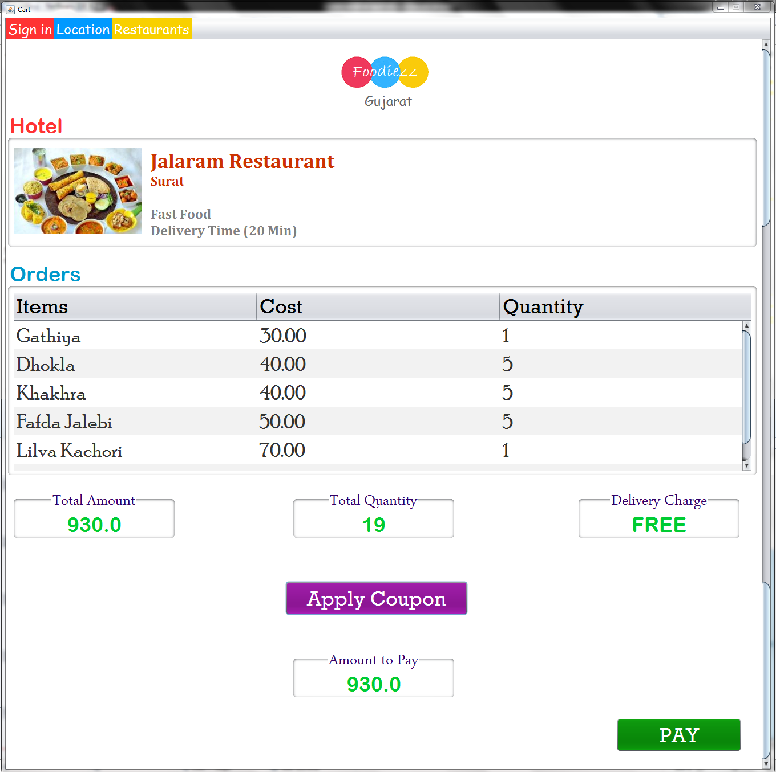

* Items to be Imported :

import java.sql.Connection;

import java.sql.DriverManager;

import java.sql.ResultSet;

import java.sql.Statement;

import javax.swing.ImageIcon;

import javax.swing.JOptionPane;

import javax.swing.table.DefaultTableModel;

* public class Cart extends javax.swing.JFrame {

Connection con;

ResultSet rs, rs1, rs2, rs3, rs4;

Statement stat;

String hotelname = null, cityname = null;

String email = JOptionPane.showInputDialog("<html><font size = 15 face = Rockwell color = blue>Enter your Emailid");

}

* Code under Opening of Form :

DefaultTableModel t = (DefaultTableModel) ItemTab.getModel();

setLocationRelativeTo(null);

ACLabel.setVisible(false);

try{

Class.forName("java.sql.Driver");

con = DriverManager.getConnection("jdbc:mysql://localhost/vatsalproject", "root", "mysql");

stat = con.createStatement();

String Hotelquery = "Select * from Cart;";

rs1 = stat.executeQuery(Hotelquery);

while(rs1.next()){

String pn = rs1.getString("Hotel");

if(pn.equals("Foodingo")){

Hotel.setIcon(new ImageIcon("H:\\Vatsal\\Foodiezz\\src\\Images\\Cart\\Surat\\Foodingo.jpg"));

Hotel.setText("<html><b> Foodingo <br> <Font size = 6> Surat <br><br> <font color = gray> Fast Food <br> Delivery Time (20 Min) </font>");

hotelname = "Foodingo";

cityname = "Surat";

}

if(pn.equals("Krish bhog")){

Hotel.setIcon(new ImageIcon("H:\\Vatsal\\Foodiezz\\src\\Images\\Cart\\Surat\\Krish bhog.jpg"));

Hotel.setText("<html><b> Krish Bhog <br> <Font size = 6> Surat <br><br> <font color = gray> Fast Food <br> Delivery Time (15 Min) </font>");

hotelname = "Krish Bhog";

cityname = "Surat";

}

if(pn.equals("Patel Agency")){

Hotel.setIcon(new ImageIcon("H:\\Vatsal\\Foodiezz\\src\\Images\\Cart\\Surat\\Patel Agency.jpg"));

Hotel.setText("<html><b> Patel Agency <br> <Font size = 6> Surat <br><br> <font color = gray> Fast Food <br> Delivery Time (20 Min) </font>");

hotelname = "Patel Agency";

cityname = "Surat";

}

if(pn.equals("Laziz Pizza")){

Hotel.setIcon(new ImageIcon("H:\\Vatsal\\Foodiezz\\src\\Images\\Cart\\Surat\\Laziz Pizza.jpg"));

Hotel.setText("<html><b> Laziz Pizza <br> <Font size = 6> Surat <br><br> <font color = gray> Fast Food <br> Delivery Time (25 Min) </font>");

hotelname = "Laziz Pizza";

cityname = "Surat";

}

if(pn.equals("Jalaram Restaurant")){

Hotel.setIcon(new ImageIcon("H:\\Vatsal\\Foodiezz\\src\\Images\\Cart\\Surat\\Jalaram Restaurant.jpg"));

Hotel.setText("<html><b> Jalaram Restaurant <br> <Font size = 6> Surat <br><br> <font color = gray> Fast Food <br> Delivery Time (20 Min) </font>");

hotelname = "Jalaram Restaurant";

cityname = "Surat";

}

if(pn.equals("Cake Square")){

Hotel.setIcon(new ImageIcon("H:\\Vatsal\\Foodiezz\\src\\Images\\Cart\\Surat\\Cake Square.jpg"));

Hotel.setText("<html><b> Cake Square <br> <Font size = 6> Surat <br><br> <font color = gray> Fast Food <br> Delivery Time (40 Min) </font>");

hotelname = "Cake Square";

cityname = "Surat";

}

if(pn.equals("Makhan Bhog")){

Hotel.setIcon(new ImageIcon("H:\\Vatsal\\Foodiezz\\src\\Images\\Cart\\Ahemdabad\\Makhan Bhog.jpg"));

Hotel.setText("<html><b> Makhan Bhog <br> <Font size = 6> Ahmedabad <br><br> <font color = gray> Fast Food <br> Delivery Time (15 Min) </font>");

hotelname = "Makhan Bhog";

cityname = "Ahemdabad";

}

if(pn.equals("Shan Chi")){

Hotel.setIcon(new ImageIcon("H:\\Vatsal\\Foodiezz\\src\\Images\\Cart\\Ahemdabad\\Shan Chi.jpg"));

Hotel.setText("<html><b> Shan Chi <br> <Font size = 6> Ahmedabad <br><br> <font color = gray> Fast Food <br> Delivery Time (15 Min) </font>");

hotelname = "Shan Chi";

cityname = "Ahemdabad";

}

if(pn.equals("Vimal Ice Creams")){

Hotel.setIcon(new ImageIcon("H:\\Vatsal\\Foodiezz\\src\\Images\\Cart\\Ahemdabad\\Vimal Ice Creams.png"));

Hotel.setText("<html><b> Vimal Ice Cream <br> <Font size = 6> Ahmedabad <br><br> <font color = gray> Fast Food <br> Delivery Time (15 Min) </font>");

hotelname = "Vimal Ice Creams";

cityname = "Ahemdabad";

}

if(pn.equals("Breadliner")){

Hotel.setIcon(new ImageIcon("H:\\Vatsal\\Foodiezz\\src\\Images\\Cart\\Ahemdabad\\Breadliner.png"));

Hotel.setText("<html><b> Breadliner <br> <Font size = 6> Ahmedabad <br><br> <font color = gray>Fast Food <br> Delivery Time (30 Min) </font>");

hotelname = "Breadliner";

cityname = "Ahemdabad";

}

if(pn.equals("Dhosa Platform")){

Hotel.setIcon(new ImageIcon("H:\\Vatsal\\Foodiezz\\src\\Images\\Cart\\Ahemdabad\\Dhosa Platform.png"));

Hotel.setText("<html><b> Dhosa Platform <br> <Font size = 6> Ahmedabad <br><br> <font color = gray> Fast Food <br> Delivery Time (20 Min) </font>");

hotelname = "Dhosa Platform";

cityname = "Ahemdabad";

}

}

String Qtyquery = "Select sum(Qty) from Cart;";

rs2 = stat.executeQuery(Qtyquery);

while(rs2.next()){

String qty = rs2.getString(1);

QtyLabel.setText(qty);

}

String Itemquery = "Select * from cart;";

rs3 = stat.executeQuery(Itemquery);

while (rs3.next()){

String it = rs3.getString("Item");

String ct = rs3.getString("Cost");

String qt = rs3.getString("Qty");

Object x [] = {it, ct, qt};

t.addRow(x);

}

String Totalquery = "Select sum(cost * qty) from cart;";

rs4 = stat.executeQuery(Totalquery);

while (rs4.next()){

double dc = Double.parseDouble(rs4.getString(1));

TALabel.setText("" + dc);

if(dc > 500){

DelCLabel.setText("FREE");

dc += 0;

}

else if(dc > 400 && dc < 500){

DelCLabel.setText("30.00");

dc += 30;

}

else if(dc > 300 && dc < 400){

DelCLabel.setText("60.00");

dc += 60;

}

else if(dc < 300){

DelCLabel.setText("80.00");

dc += 80;

} APLabel.setText(""+dc);

String createquery = "Create Table " + email + "("

+ "Items varchar(30),"

+ "Price decimal(10,2),"

+ "Qty int(4),"

+ "Total_Price decimal(10,2),"

+ "Hotel varchar(30),"

+ "City varchar(30),"

+ "Date_of_Order date,"

+ "Time_of_Order time);";

stat.executeUpdate(createquery);

}

}

catch(Exception e){

JOptionPane.showMessageDialog(this, "Error in Data Transaction",null,-2);

}

* Code under H:\New folder\btn\appcop.JPG Button :

Coupons.main(null);

* ‘Apply Coupon Frame’ opens on Clicking H:\New folder\btn\appcop.JPG Button :

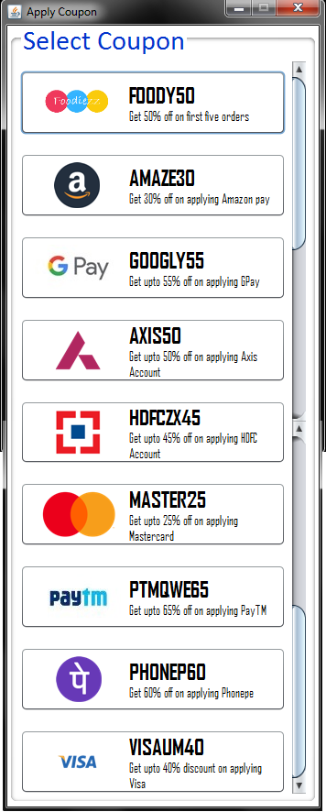

* Code under 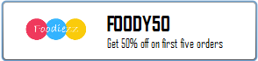 Button :

Cart.CoupBtn.setVisible(false);

Cart.ACLabel.setVisible(true);

Cart.ACLabel.setText(jButton8.getText());

double atp = Double.parseDouble(Cart.APLabel.getText());

Cart.APLabel.setText("" + (atp - (atp * 0.65d)));

this.dispose();

* Cart will get Applied Coupon Clicking  Button :

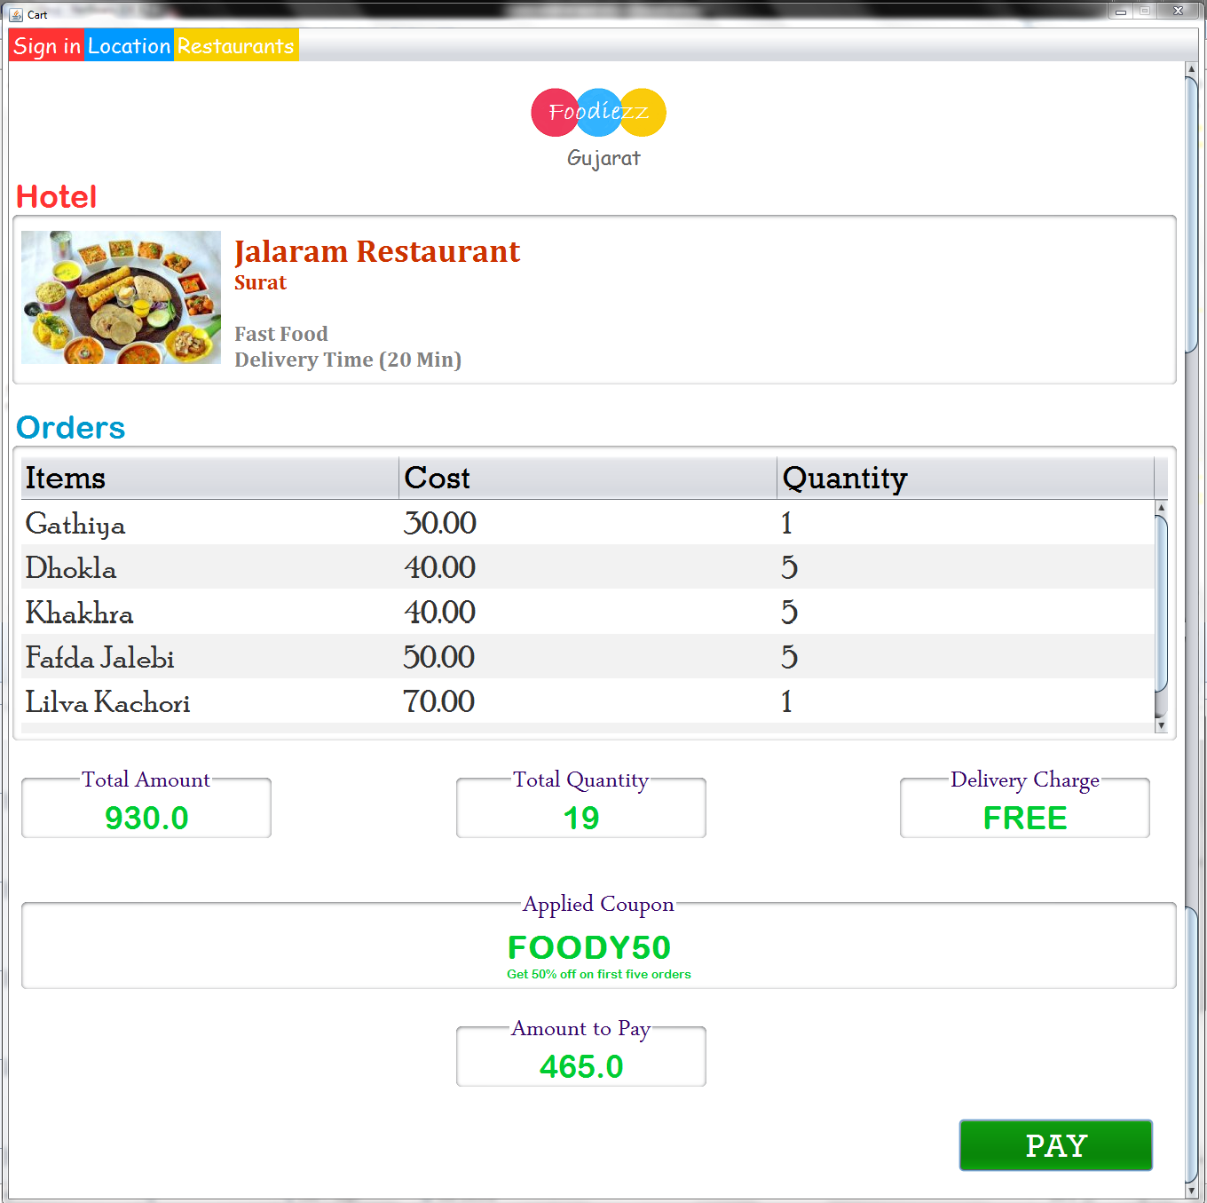

* Code under F:\New folder\btn\pay.JPG Button :

DefaultTableModel t = (DefaultTableModel) ItemTab.getModel();

try{

Class.forName("java.sql.Driver");

con = DriverManager.getConnection("jdbc:mysql://localhost/vatsalproject", "root", "mysql");

stat = con.createStatement();

int c = t.getRowCount();

for(int row = 0; row<c; row++){

String item = (String) t.getValueAt(row, 0);

String cost = (String) t.getValueAt(row, 1);

String qty = (String) t.getValueAt(row, 2);

String updatequery = "Insert into " + email + " values('" + item + "', " + cost + "," + qty + ", Price * Qty, '" + hotelname + "', '" + cityname + "', Curdate(), Curtime());" ;

stat.executeUpdate(updatequery);

}

JOptionPane.showMessageDialog(this, "<html><body bgcolor = white><font size = 15 face = Rockwell color = green>Successfully Payment Complete<br><font color = red>Enjoy <font color = 0099FF>your <font color = FFCC00>Meal", null, -1);

if(cityname.equals("Surat"))

Project_Frame._4_Main_Order_Gujarat_Surat.main(null);

if(cityname.equals("Ahemdabad"))

Project_Frame._4_Main_Order_Gujarat_Ahemdabad.main(null);

this.dispose();

}

catch(Exception e){

JOptionPane.showMessageDialog(this, "Error in Payment",null,-2);

}

* On Clicking F:\New folder\btn\pay.JPG Button :

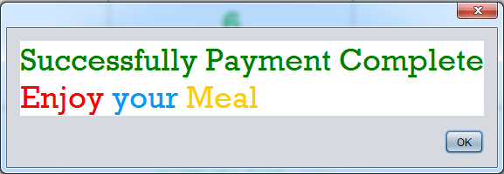

After Clicking ‘OK’ Restaurant List (Pg. no.: 21) opens again

References

In order to work on this project titled – FOODIEZZ , the following books and literature are referred by me during the various phases of development of the project.

1. http://www.mysql.org/

2. <http://www.netbeans.org/>

3. <http://www.stackoverflow.com/>

4. <http://www.ezgif.com/>

5. Informatics Practices for class 12th by SUMITA ARORA